Dealing with Errors
#1 When you see this screen pop up NEVER press yes
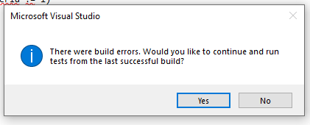
All this does is run the last working version of your system and over time will result in further corruption of the code and in time the whole compile process.
#2 Find the error
When you press no the error(s) will be visible in the error output window…
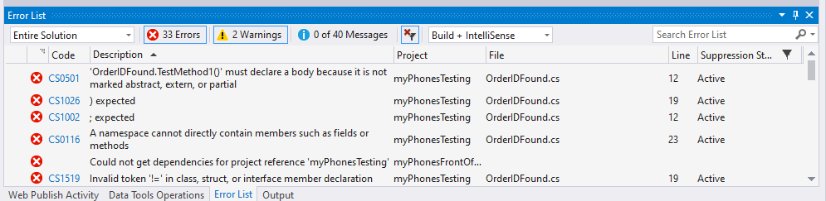
To view the error in more detail double click it in the list, this will take you to the section of code with the problem…
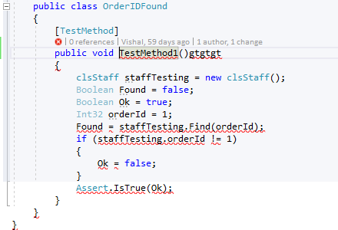
In this case there is garbage text next to the function.
Fix the error and then run your tests.
If there are still errors work through them one at a time until they are all fixed.
#3 Never continue writing more code while there are still errors to fix
This is only going to dig the hole deeper and create more problems
#4 Don’t expect to fix errors on your own
Errors can be difficult, try and fix them if you can but there is no shame in seeking help
#5 Always provide the actual error message
A line of code with red underlining tells people nothing always provide as much detail of the error as possible by holding the mouse over any red underlining in your code and screen capturing the actual error message

